FUNDAMENTAL OF WEB TECHNOLOGY

**SHORT REPORT**

# RAI MUHAMMAD IBRAHIM BADAR

## 190071703

**SEMANTIC MARKUP**

**In HTML, elements that clearly describe there meaning and purpose to both the developer and the web browser are known as semantic elements. Examples of semantic elements in my portfolio site include:**

* **<header>**
* **<nav>**
* **<article>**
* **<aside>**
* **<section>**
* **<figure>**
* **<figcaption>**
* **<footer>**

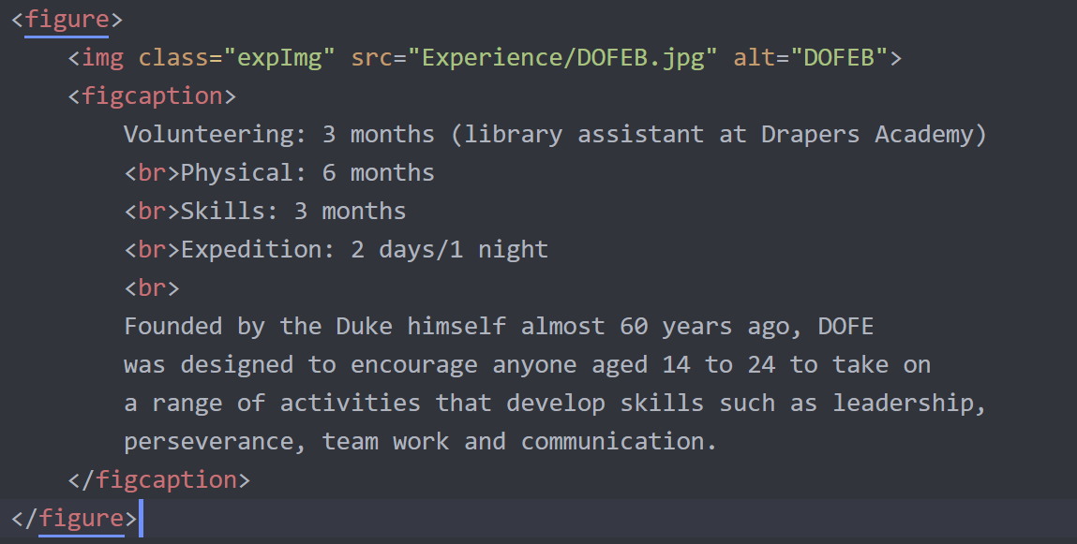**Semantic elements clearly define the content they hold. Semantic markup is important as it makes code clear and easy to maintain. For example,**

**makes it clear that here I am using a figure with an image and a caption to go with it. This will be easy to find when scrolling through my code. But, if instead I was to use a div with a class called figure it will be much harder to find as it will hide between all the other div’s in my code. Semantic elements also help the site become more accessible as voice reading software’s, screen reading software’s and keyboard navigation widely depends on the use of semantic elements. Making your site more accessible not only allows more types of users to access it but also improves there overall experience which improves traffic. Semantic markup improves your websites machine readability, search engines can use this to better understand what your webpage is about and improve your rankings in the search results with search engine optimization.**

**WEB TECHNOLOGIES/FRAMEWORKS**

**For this project I have made use of HTML, CSS, JavaScript and PHP. If I were to reconduct this project I would attempt it in a way which enables me to be faster and more efficient and allows my website to be more dynamic. To achieve this I would use angular, Angular is a framework which allows you to create dynamic websites which can be accessed on multiple devices with different screen sizes and input methodologies. It also provides server side rendering, the ability to render JavaScript on the server rather than in the browser, and code splitting, which is where JS is split into smaller chunks that can be provided on demand to decrease web load times and increase user experience. Angular also features templates to increase your development speed and time when it comes to writing basic code. Zend is another good framework that stands out to me due to its approach on making websites more secure. This is especially useful if the blog allowed other users to make accounts, as you would like to protect user data. I would also use libraries such as jQuery instead of writing my own JavaScript, to make event handling and animation much simpler and versatile over multiple browsers. Another framework that is appealing to use is Symfony. Symfony comes with many plug-ins and a library full of tools that allows you to avoid tiresome, repetitive tasks. It’s Model-View-Controller Design allows you to work as a team, clearly displaying everyone’s work which is more practical for industrial web development.**